1. 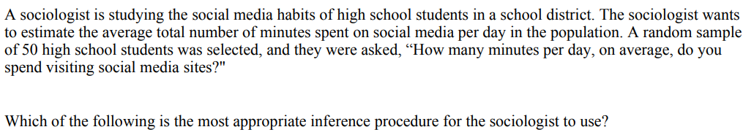

(A) A one-sample z-interval for a population proportion

(B) A one-sample t-interval for a population mean

(C) A two-sample z-interval for a difference between proportions

(D) A two-sample t-interval for a difference between means

1. 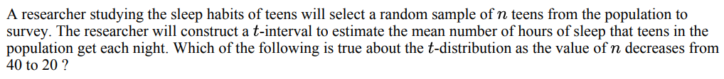

(A) The center decreases, and the area in the tails of the distribution increases.

(B) The center increases, and the area in the tails of the distribution decreases.

(C) The center remains constant, and the area in the tails of the distribution remains constant.

(D) The center remains constant, and the area in the tails of the distribution decreases.

(E) The center remains constant, and the area in the tails of the distribution increases.

1. 

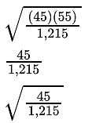

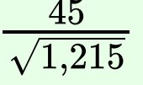A. D.

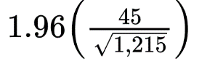B. E.

C.

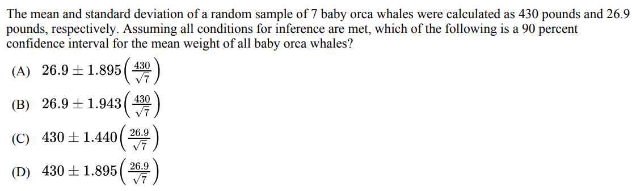



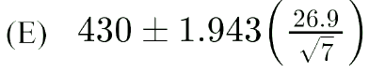

1. 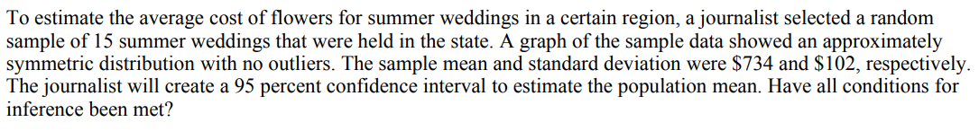

(A) Yes, all conditions have been met.

(B) No, the 15 weddings in the sample were not selected at random.

(C) No, the sample size is not large enough to assume the sampling distribution of sample means is approximately normal.

(D) No, because the graphical display is approximately symmetric it cannot be assumed that the sampling distribution of sample means is approximately normal.

(E) No, the sample size of 15 is not less than 10 percent of all weddings in the state.

1. 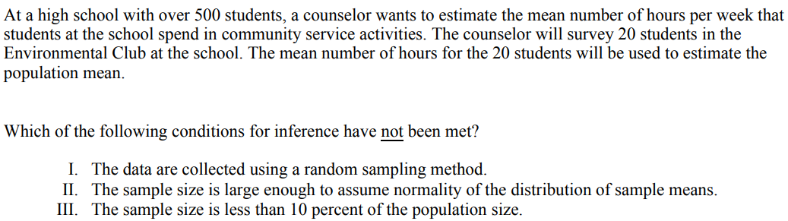
2. I only
3. II only
4. III only
5. I and II only
6. I, II and III

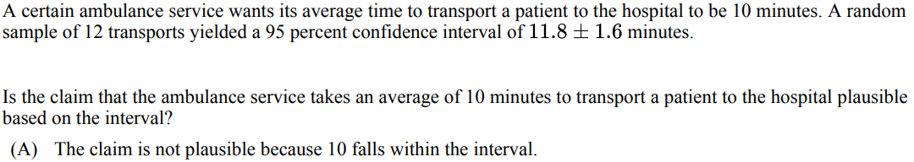

1. V



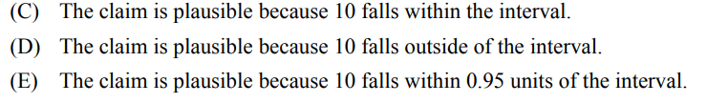

1. 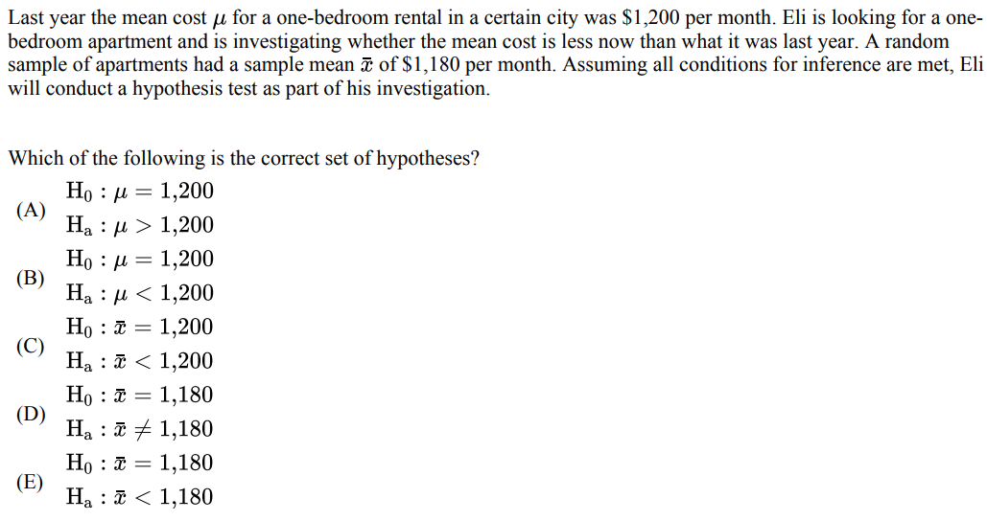
2. 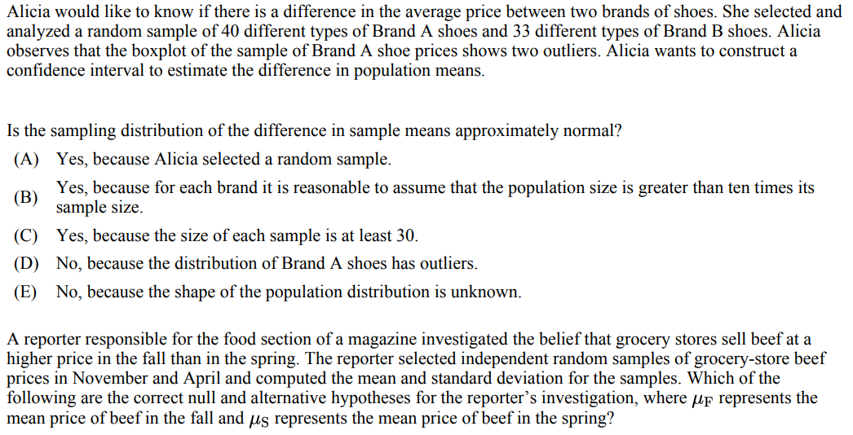

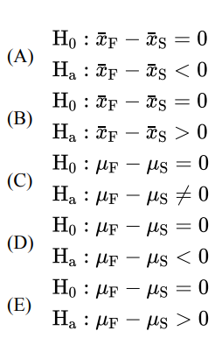

1. 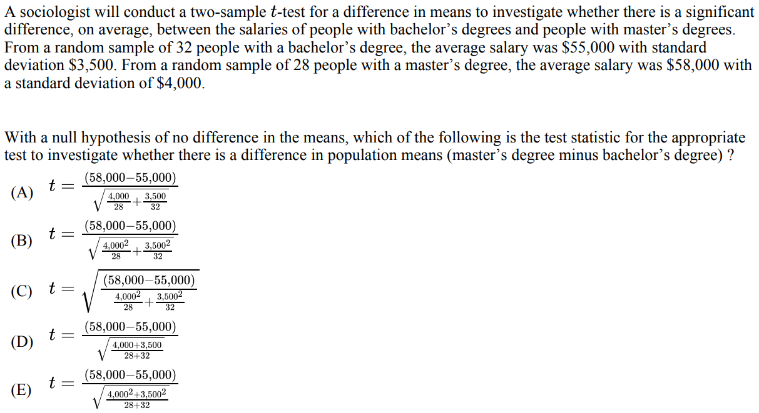
2. 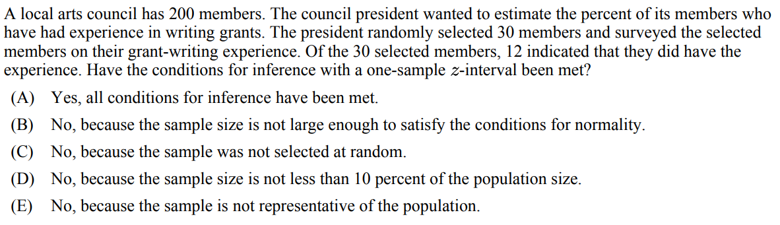

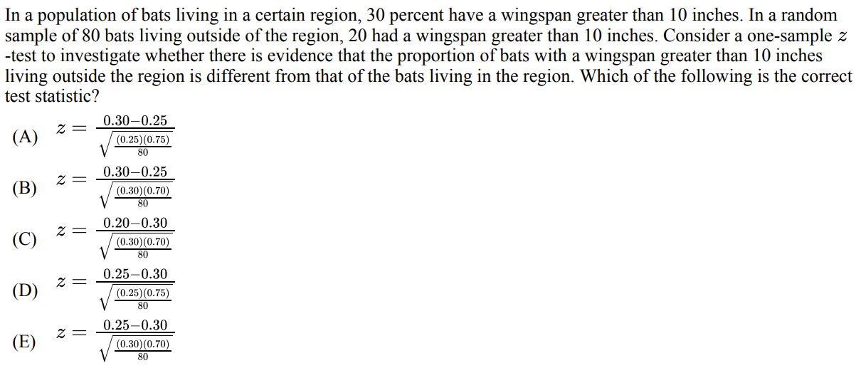

2. 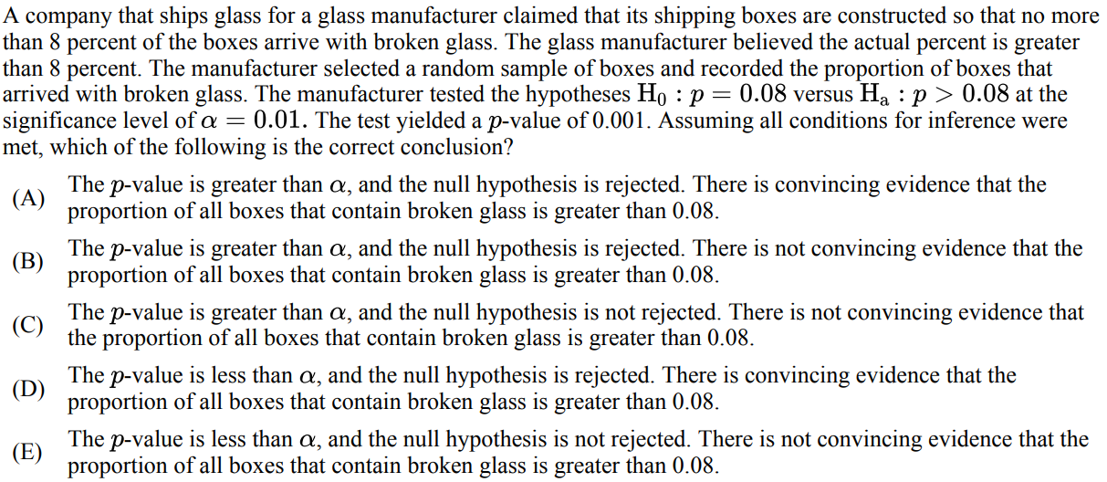
3. 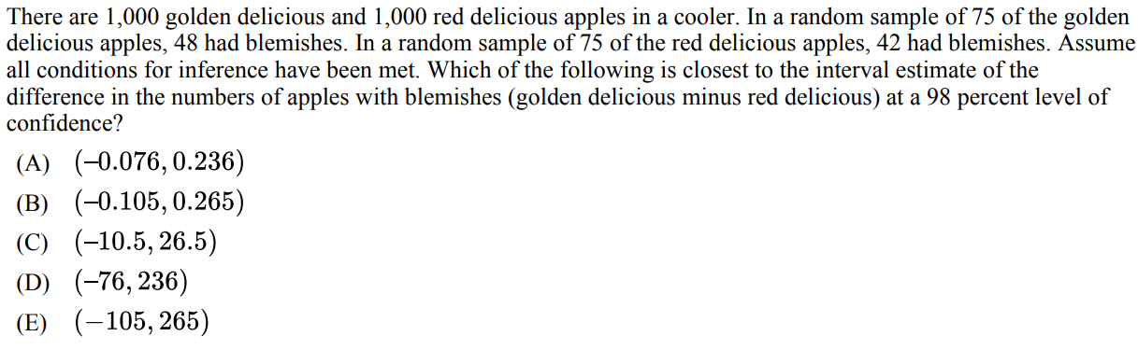

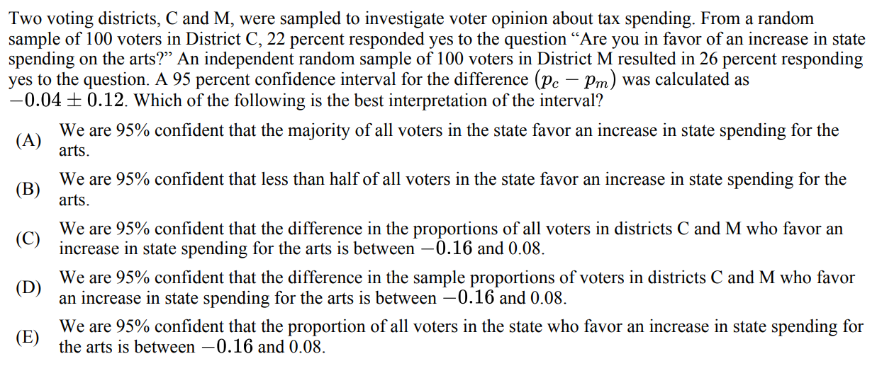

1. 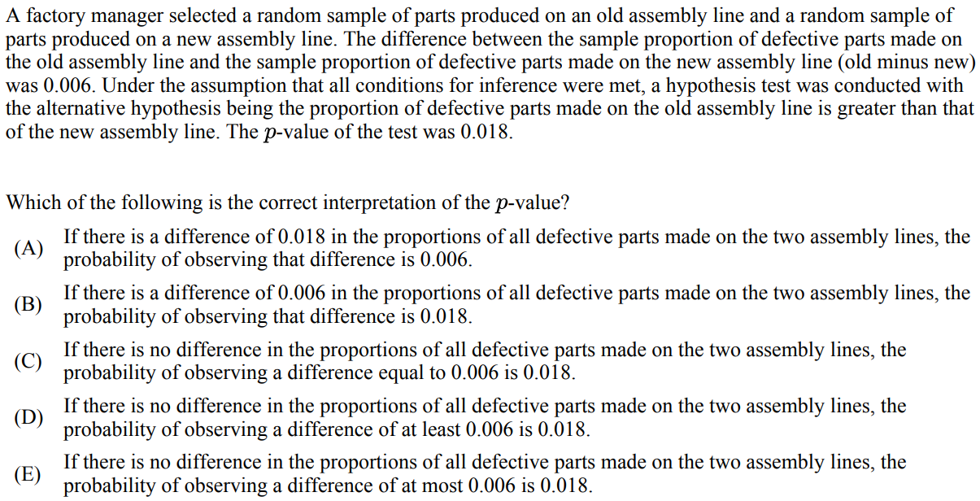
2. 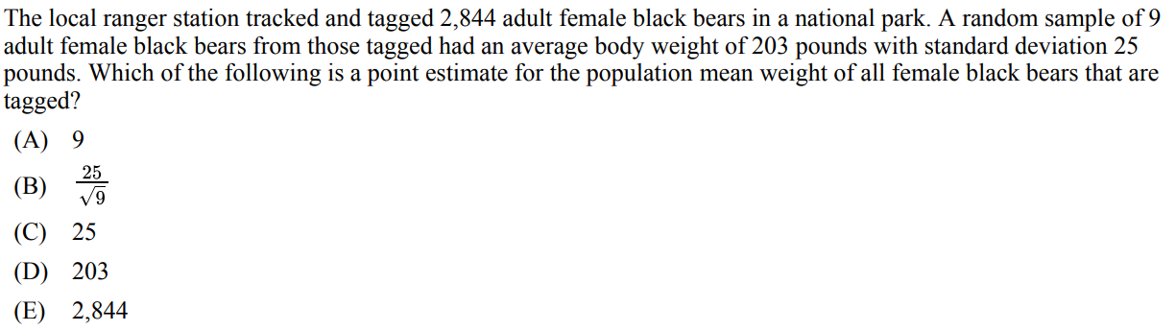
3. 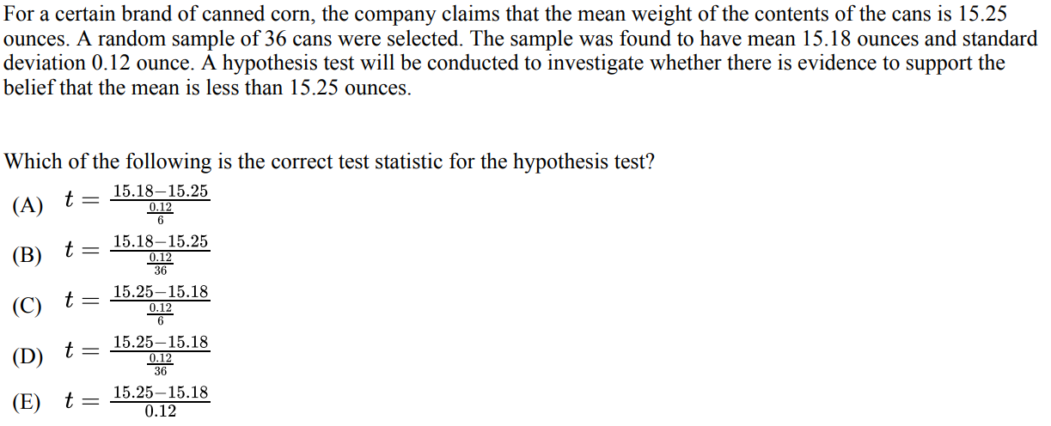
4. 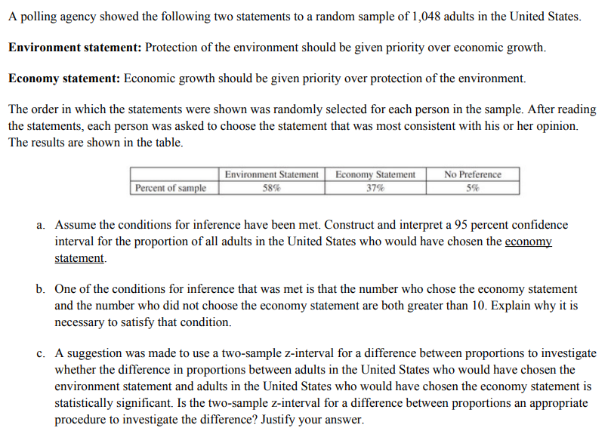
5. 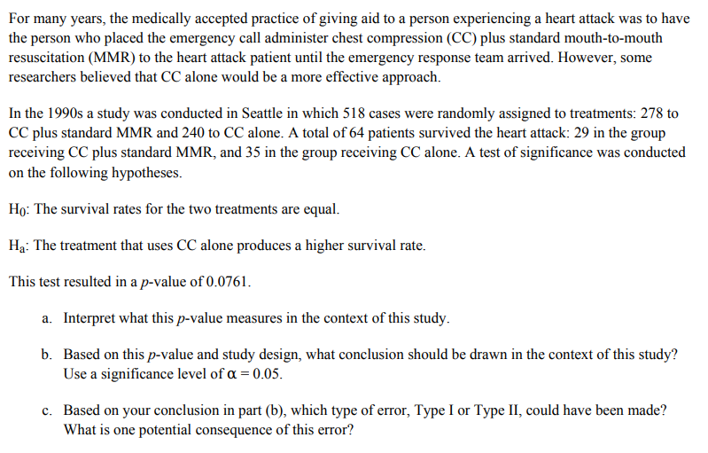
6. 